**NAME-AYUSH KACHHADIYA**

**SAP ID-500095872**



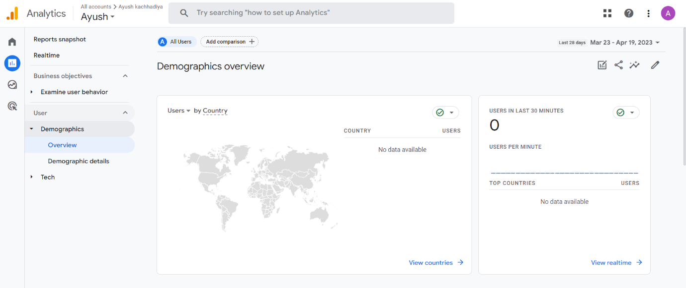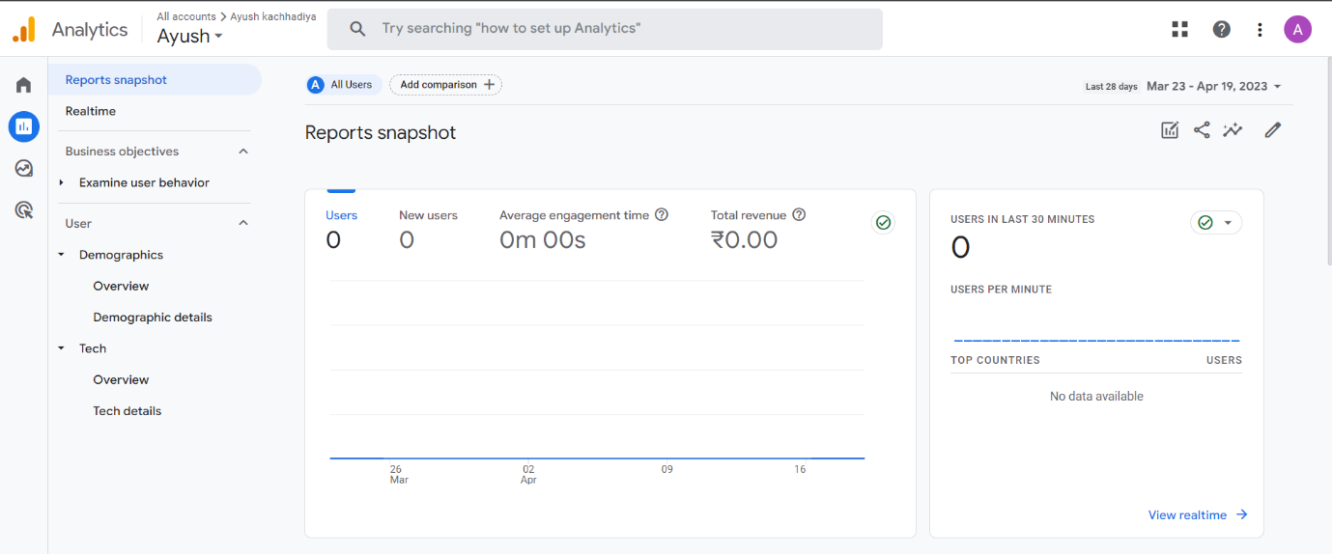

Different types of reports of Google Analytics

1.Audience Reports: This report offers information on the age, gender, location, and interests of your website users as well as their demographic and geographic features.

2.Acquisition Reports: This report reveals the sources of your website's traffic, such as search engines, social media, email marketing efforts, and other referring sites.

3.Behavior Reports: These reports provide information on how visitors use your website, including the pages they visit, how long they stay, and the activities they do.

4.Conversion Reports: These reports track user behaviours that lead to conversions, like making a purchase or submitting a contact form.

5.E-commerce Reports: This report offers insights into the operation of your online store, including information on sales, product performance, and clientele.

6.Real-Time Reports: This report offers up-to-date details about the activity on your website, such as the number of visitors you have right now, the pages they are visiting, and the activities they are taking.

7.Custom Reports: With the help of this report, you can design reports that are suited to your particular requirements and objectives.